Producing Reports:
- Duplicate the “ECI Research” Folder to your personal google drive OR add a shortcut to your personal drive. Create
- Pick a country from the previous reports from 2013-2018 data and update it to 2021 data. Use templates from 2013-2018 data.
- Duplicate the code files.
- Run code in this order:
  - Comprehensive
  - Budget Allocation Greedy_ new
  - Budget Allocation Greedy_plot
  - Sensitivity 2
- Note: you need to update the countries’ name and comparable countries (search #TO DO for the places)
- You will need the graphs, GDP growth, ECI numbers, R-squared, etc. for the report, so make sure to export/save them
- Make sure to updates paths to Files to the respective folders
- Introduce, compare, and contrast the new findings with past trends, noting any changes, and trends for the country and in comparison to other similar countries
- Check the numbering for Tables/Charts
- Format Tables in the same style

Updating the Presentation: Updated Consolidated ECI Presentation
- Look at slide 116 (India)
- Make 3 slides per country
Notes About Comprehensive Code:

- Ignore all these
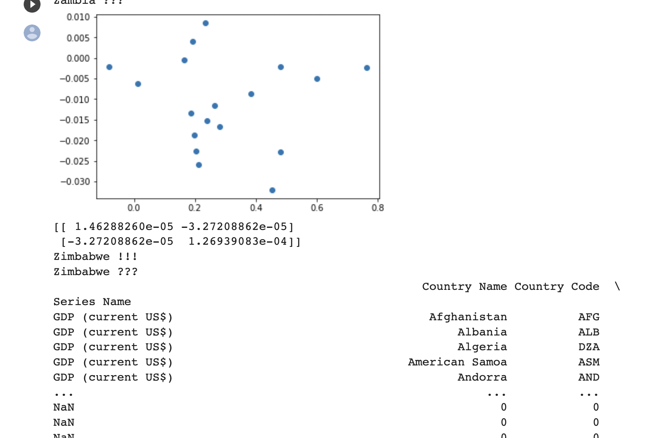

- Need this r squared value

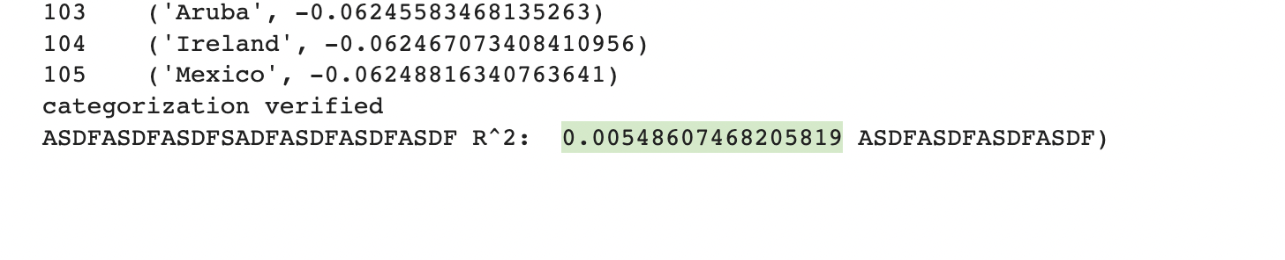
- Graph is where you can stop running
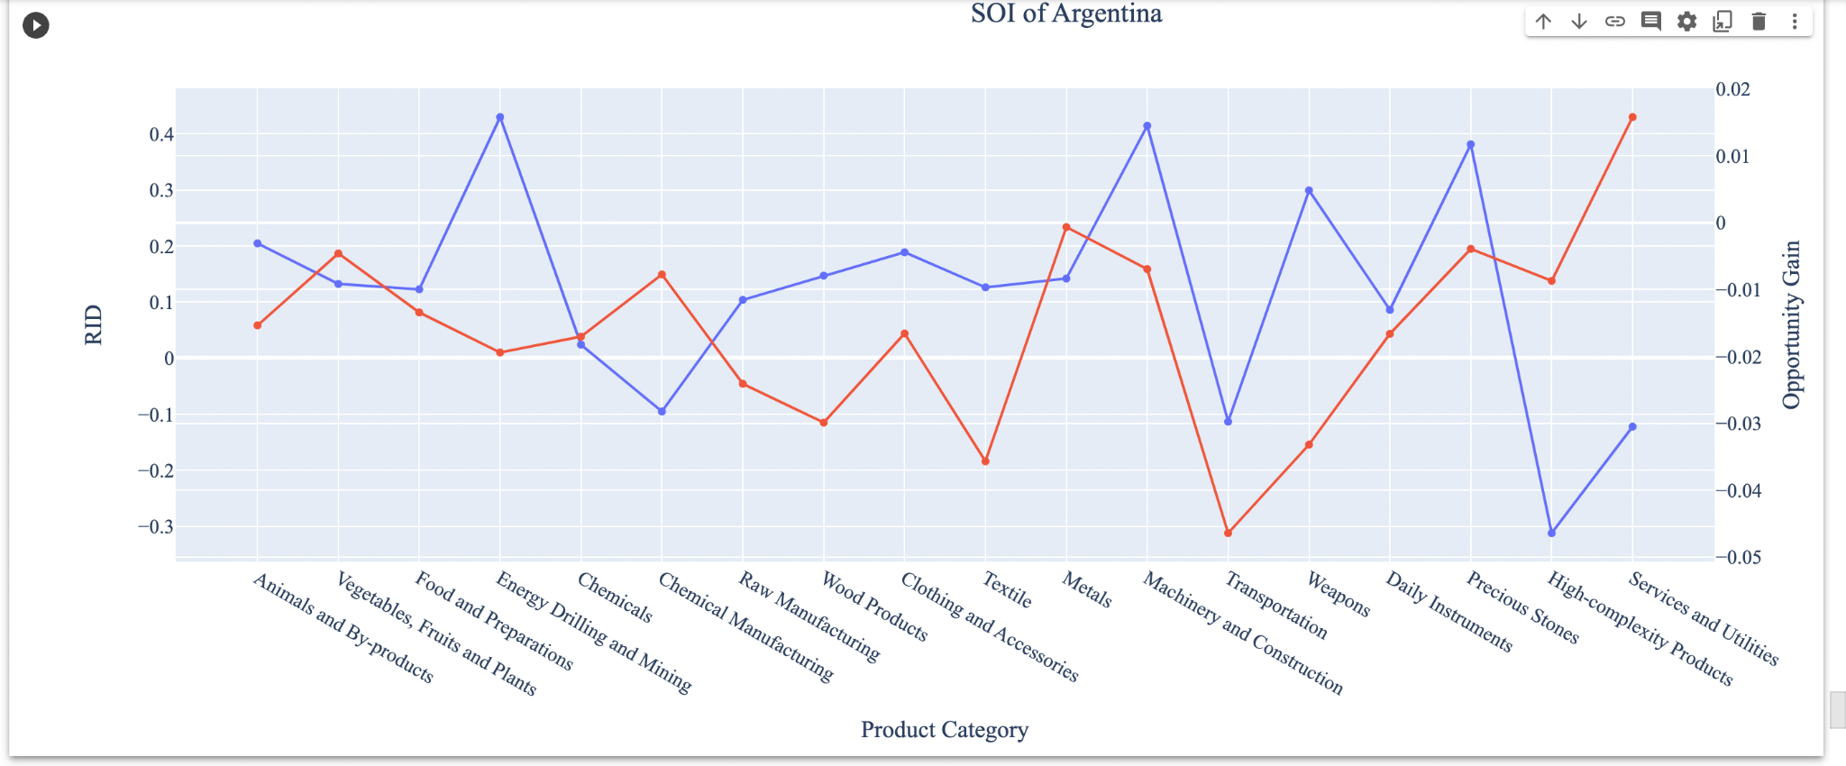

Notes about greedy new
- Update main_country name
- Change 5, 10, 15, 20: each one will take about 30 minutes so just go through that
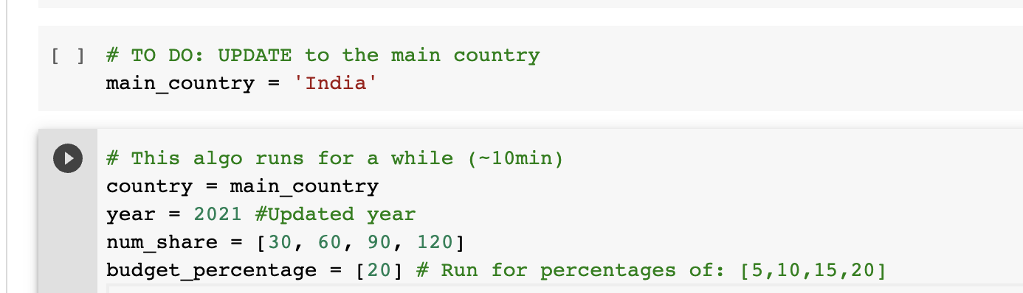

Notes about greedy plot & sensitivity 2
- Straightforward; just go ahead and run each cell
- Download paths to your own drive

